1. 题目

E07618: 病人排队

sorttings, <http://cs101.openjudge.cn/practice/07618/>

思路:分年轻人和老年人两个列表

代码：

n = int(input())

elderly = []

non_elderly = []

for _ in range(n):

patient_id, age = input().split()

age = int(age)

if age >= 60:

elderly.append((patient_id, age))

else:

non_elderly.append((patient_id, age))

elderly.sort(key=lambda x: -x[1])

sorted_patients = elderly + non_elderly

for patient in sorted_patients:

print(patient[0])

代码运行截图 （至少包含有"Accepted"）

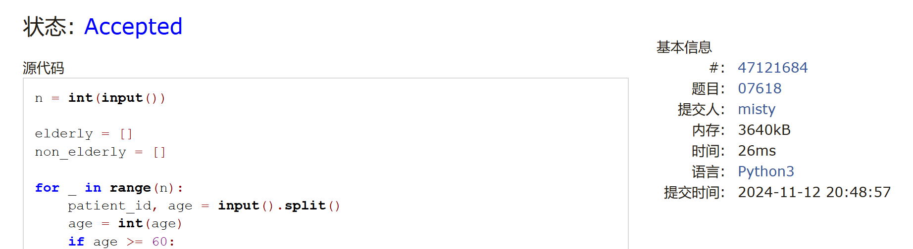

E23555: 节省存储的矩阵乘法

implementation, matrices, <http://cs101.openjudge.cn/practice/23555/>

代码：

n, m1, m2 = map(int, input().split())a = [[0] * n for _ in range(n)]b = [[0] * n for _ in range(n)]for _ in range(m1):

x, y, v = map(int, input().split())

a[x][y] = vfor _ in range(m2):

x, y, v = map(int, input().split())

b[x][y] = vc = [[0] * n for _ in range(n)]for i in range(n):

for j in range(n):

c[i][j] = sum(a[i][k] * b[k][j] for k in range(n))

if c[i][j] != 0:

print(i, j, c[i][j])

代码运行截图 ==（至少包含有"Accepted"）==

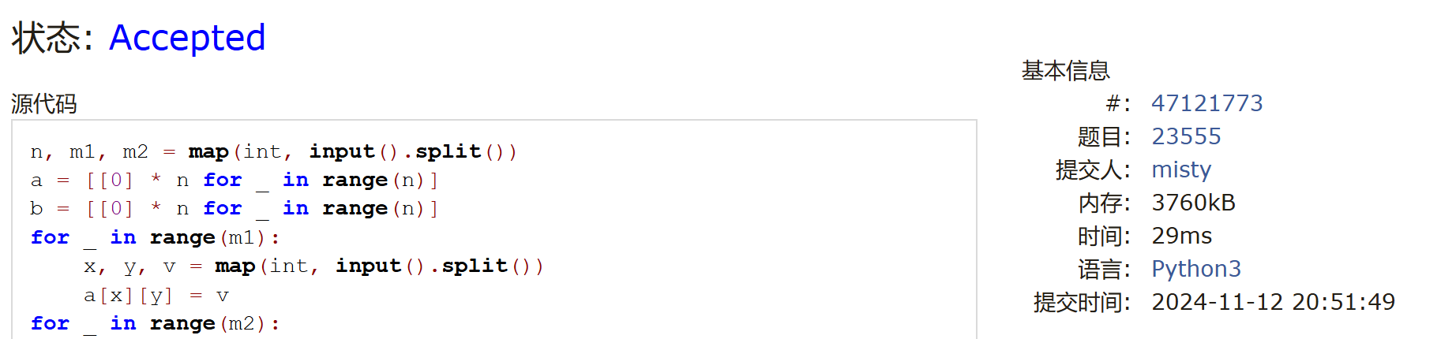

M18182: 打怪兽

implementation/sortings/data structures, <http://cs101.openjudge.cn/practice/18182/>

代码：

for _ in range(int(input())):

n,m,b = map(int, input().split(' '))

d = {}

for i in range(n):

t,x=map(int, input().split(' '))

if t not in d.keys():

d[t] = [x]

else:

d[t].append(x)

for i in d.keys():

d[i].sort(reverse=True)

d[i] = sum(d[i][:m])

dp = sorted(d.items())

for i in dp:

b -= i[1]

if b<=0:

print(i[0])

break

else:

print('alive')

代码运行截图 （至少包含有"Accepted"）

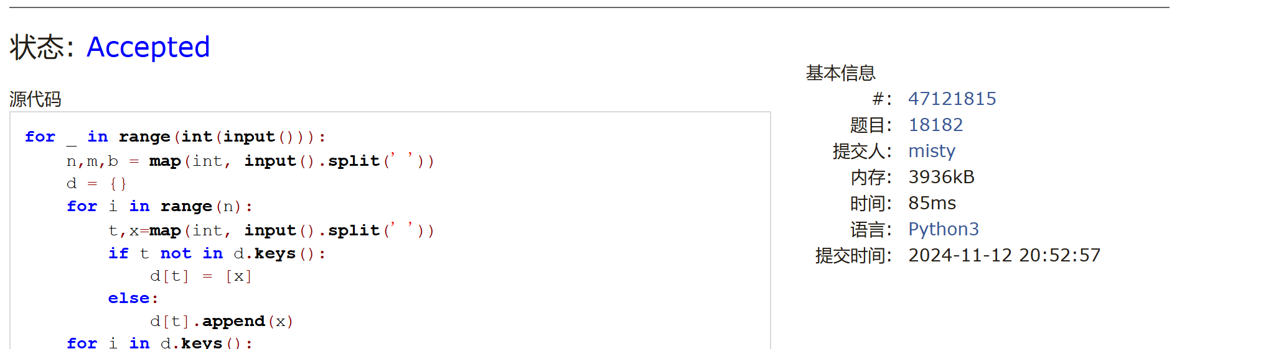

M28780: 零钱兑换3

dp, <http://cs101.openjudge.cn/practice/28780/>

代码：

n, m = map(int, input().split())coins = list(map(int, input().split()))dp = [float("inf")] * (m + 1)dp[0] = 1for i in coins:

dp[i] = 1for i in range(1, m + 1):

for coin in coins:

if i - coin >= 0:

dp[i] = min(dp[i], dp[i - coin] + 1)

#print(dp)if dp[m] == float("inf"):

print(-1)else:

print(dp[m])

代码运行截图 （至少包含有"Accepted"）

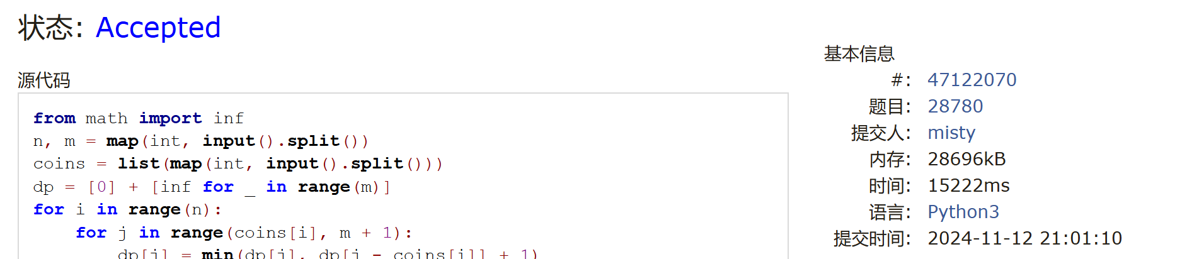

T12757: 阿尔法星人翻译官

implementation, <http://cs101.openjudge.cn/practice/12757>

代码：

tokens = [str(i) for i in input().split()]dic={"zero":0, "one":1, "two":2, "three":3, "four":4, "five":5, "six":6,

"seven":7, "eight":8, "nine":9, "ten":10, "eleven":11, "twelve":12,

"thirteen":13, "fourteen":14, "fifteen":15, "sixteen":16, "seventeen":17,

"eighteen":18, "nineteen":19, "twenty":20, "thirty":30, "forty":40,

"fifty":50, "sixty":60, "seventy":70, "eighty":80, "ninety":90,

"hundred":100, "thousand":1000, "million":1000000}

sign = 1if tokens[0]=="negative":

sign = -1

del tokens[0]

total = 0tmp = 0for i in tokens:

if i in ("thousand", "million"):

total += tmp*dic[i]

tmp = 0

continue

if i == "hundred":

tmp *= dic[i]

else:

tmp += dic[i]

print( sign * (total + tmp) )

代码运行截图 （至少包含有"Accepted"）

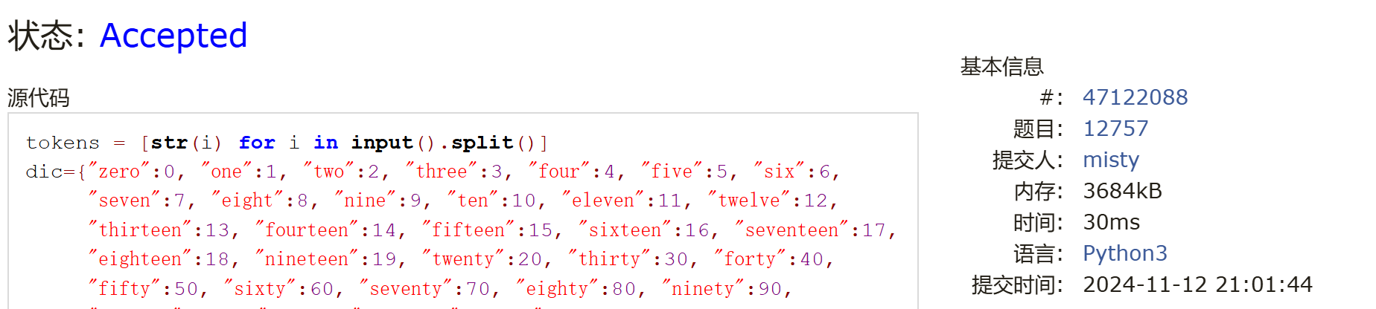

T16528: 充实的寒假生活

greedy/dp, cs10117 Final Exam, <http://cs101.openjudge.cn/practice/16528/>

代码：

n = int(input())a = []for i in range(n):

x, y = map(int, input().split())

a.append((x + 1, y + 1))a = sorted(a, key = lambda _: _[0])dp = [0] * 65for i in range(n):

for j in range(a[i][1], 62):

dp[j] = max(dp[j], dp[a[i][0] - 1] + 1)print(dp[61])

代码运行截图 （至少包含有"Accepted"）

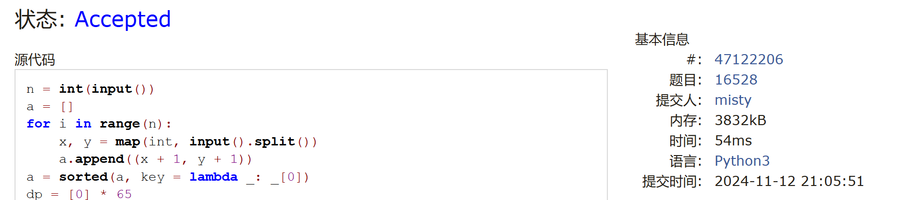

2. 学习总结和收获

(1)期中考完了该学计概了

(2)有同学说他学编程几乎不用ai，遇到困难去翻书，这样虽然解题效率低于ai，但是在查阅过程中可能更容易学到相关知识，可以试一下不那么依赖ai的学习方式。